**Electronic supplementary information**

**FUNCTIONAL POLYLACTIDE MICELLES  
FOR TARGETED DELIVERY OF PACLITAXEL**

V. A. Pigareva*

Nesmeyanov Institute of Organoelement Compounds, Russian Academy of Sciences,  
ul. Vavilova 28, str. 1, Moscow, 119334 Russia

|  |
| --- |
| **PLA-PEG** |
| Паклитаксел (Paclitaxelum)- описание вещества, инструкция, применение,  противопоказания и формула.  **PTX** |

**Figure S1.** Structures of poly(d,l-lactide)-b-(ethylene glycol methyl ether)  
diblock copolymer (PLA-PEG) and paclitaxel (PTX).

**Maghemite nanoparticles** (γ-Fe2O3) were obtained using the following technique. 30 mL of sodium hypophosphite solution were added to 70 mL of a solution of β-cyclodextrins (β-CD) (0.06 mmol) and Mohr's salt (0.66 mmol) in 0.1 M NaOH. The molar ratio of FeSO4 to NaH2PO2 was 1:1 and that of FeSO4 to β-CD (per a β-CD unit) was 10:1. A solution of sodium hypophosphite was added dropwise to the vigorously stirred reaction mixture. The reaction was carried out in an inert atmosphere. The reaction completion was determined by the complete precipitation of iron hydroxide. The mixture was stirred at room temperature in air for 24 h. The dark brown residue of maghemite nanoparticles was isolated from the solution, washed with water, and dried in air.

**The micelles were synthesized** according to the following film hydration procedure. A 20 mg sample of the copolymer was placed in a round-bottom flask and dissolved in 2 mL of THF. Then the solvent was removed on a rotary evaporator. The resulting film was dispersed in 2 mL of water. Then the suspension was exposed to ultrasonic homogenization using a tip homogenizer with a power of 750 W for 10 min with constant water cooling. As a result, a micellar suspension with a polylactide concentration of 10 mg·mL−1 was obtained.

PTX and γ-Fe2O3 loaded micelles (γ-Fe2O3/PTX/PLMs) were synthesized according to the procedure described above. The solutions of PTX were prepared by dissolving of a weighed portion of paclitaxel in THF. The solution of PTX was added to the solution of PLA-PEG in THF prior to the solvent evaporation. In addition, the calculated amount of freshly obtained magnetic nanoparticles was added upon dissolving the polymer in THF. The ultrasonic homogenization afforded an aqueous suspension of the micelles with a γ-Fe2O3 content of 0.5 wt % and PTX content of 10 wt %.

Furthermore, besides the method of combined ultrasonic dispersion, a mixture of PLMs with maghemite nanoparticles (PLMs+γ-Fe2O3(sus)) was obtained using the following method. A maghemite suspension was sonicated using ultrasound in pure water, after which the required volume of the suspension was added to the suspension of the pre-formed "empty" micelles, and then the mixture was thoroughly mixed.

**The hydrodynamic diameters** of γ-Fe2O3/PTX/PLMs were determined in a thermostatic cell by DLS at a fixed scattering angle (90°) with a Brookhaven Zeta Plus instrument. The DynaLS Software was used to estimate the intensity distribution of sizes of the particles in suspensions.

The mean hydrodynamic diameter of the ternary micelles γ-Fe2O3/PTX/PLMs was found to be 30 nm (see Fig. S2, curve 3). The colloidal stability of γ-Fe2O3/PTX/PLMs was monitored for 24 h. The suspension was stable and did not undergo phase separation for at least 3 h. Then slow sedimentation occurred. However, the vigorous resuspension allowed for obtaining a stable suspension again. At the same time, a different picture was observed for the suspension PLMs+γ-Fe2O3(sus) prepared by mixing the nanoparticle and pre-formed PLMs (see Fig. S2, curve 1). In addition to the particles with the size corresponding to the micelle diameter, the nanoparticles with a smaller size were detected in the system. After a few minutes, the aggregates appeared in the system, while the "empty" micelles remained in the mixture PLMs+γ-Fe2O3(sus).

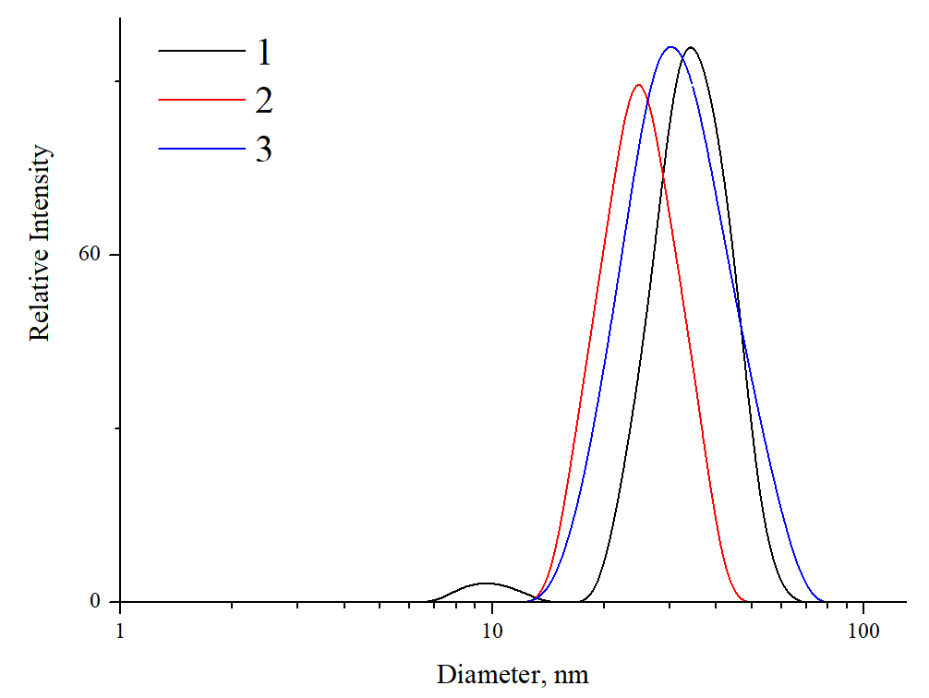

**Figure S2.** Relative intensity distribution of the hydrodynamic diameters of PLMs+γ-Fe2O3(sus) (***1***), PLMs (***2***),  
and γ-Fe2O3/PTX/PLMs (***3***). The concentration of the micelles was 0.5 mg/mL; Tris buffer, pH = 7.0.

The results obtained allow us to conclude that the method for obtaining the system by simply mixing PLMs and maghemite nanoparticles did not involve the inclusion of magnetic nanoparticles. At the same time, the method of cooperative ultrasonic dispersion of the polymer film with maghemite particles described in the work did not reveal any individual aggregated particles in the suspension, which may indicate the successful inclusion of γ-Fe2O3 into PLMs.

While biodegradable PLMs are known to withstand **enzymatic hydrolysis** for a certain time period, which allows them to deliver a bioactive cargo prior to decomposition, the incorporation of both γ-Fe2O3 and PTX in the PLA core of micelles could violate the structure of the core and result in the fast enzymatic hydrolysis. To hydrolyze the ester bonds in PLMs, an enzyme specific to PLA, pancreatic lipase, was used. The hydrolysis process was followed by a change in the hydrodynamic sizes.

The PLA-specific enzyme pancreatic lipase was used to investigate the resistance of the ternary PLMs to hydrolysis. Two major parameters were followed. First one is the time when the micelles start to lose their aggregative stability but the fraction of the PLMs with the initial diameter remains significant. The second one is the time when a fraction of the initial PLMs vanishes. The micelles 30 nm in diameter were observed in a suspension even in 1 h after the enzyme addition. Thus, the micelles show stability to hydrolysis for a time sufficient to be used in the targeted delivery. On the other hand, in 24 h of incubation, the individual sizes of the micelles ceased to be recorded due to the enzymatic hydrolysis, demonstrating suitable biodegradation of nanocontainer. This makes PLMs-based nanocontainers for delivery of PTX promising candidates as biodegradable carriers.

**The** **magnetosensitive behavior** of the ternary system was demonstrated. The micelles containing both 10 wt % of PTX and 0.5 wt % of γ-Fe2O3 were prepared using the cooperative ultrasonic dispersion method. The resulting suspension was transferred to the Eppendorf tube, after which it was fixed using a stand on a neodymium magnet. The internal magnetic field was 160 ± 10 mT induced by the magnet led to the accumulation of γ-Fe2O3/PTX/PLMs near the magnetic field source. The magnetic flux density was measured with a WT10A Teslameter (Weite Magnetic Technology, PRC). After 30 min of the magnetic field induced separation, the supernatant was analyzed by light-scattering. No particles were detected in the supernatant. This reflects the modification of PLMs with γ-Fe2O3 and their resulting magnetic sensitivity. In parallel, the suspension in the Eppendorf tube was placed away from the magnet. Within 30 min, a visual phase separation was observed for the suspension on the magnet, which was not observed for the system outside the magnetic field. After 30 min of the magnetically induced separation, the supernatant was analyzed by light scattering. No particles were detected in the supernatant. At the same time, it was previously shown that the suspension outside the magnetic field exhibits a longer stability against sedimentation. This reflects the modification of the PLMs with γ-Fe2O3 and their resulting magnetic sensitivity.